REQUEST FOR DECISION
To: Development & Planning Services Committee
From: Planning Analyst & Manager of Planning and Building
Title: ZON 1290 A-1, A-2, and A-3 Zones (SSMUH)
Date: April 15, 2024

Executive Summary/Purpose:
This is the third of five reports on changes to Zoning Bylaw 2303 in response to BC’s new housing legislation.
This report outlines the A-1 through A-3 Zone density increases, adapting Zoning Bylaw 2303 to Small Scale Multi Unit Housing (SSMUH) legislation. Given the rural context, alignment of the Urban Containment Boundary (UCB), and minimal extent of municipal utility services, the changes to density and Bylaw regulations are comparatively minor; hence, the names of these zones are proposed to remain unchanged.

Motion for Consideration:

THAT: a bylaw be prepared for Council’s consideration that would replace the A-1 (Agriculture
Zone), A-2 (Rural Holding Zone) and A-3 (Small Holding Zone) with A-1 (Agriculture Zone), A-2 (Rural Holding Zone) and A-3 (Small Holding Zone).

Staff Recommendation:
That the Motion for Consideration be adopted.

Background:

SMUHH Policy Manual
The Housing Amendment Statute policy manual (the “Policy”) concerns itself primarily with urban, serviced lands; however, it also set outs policy that must be considered in the rural or ALR context. This is because the legislation requires that all local governments allow a one secondary suite or an accessory dwelling unit instead of one single family dwelling - only - on a parcel. The new legislation has gone the step further to add the option of a detached dwelling. The Policy cites the following objectives for the rural context:
- recognizing and maintaining consistency with the rural and semi-rural characteristics of the lots and jurisdictions to which they will apply,
- discouraging and mitigating the impacts of sprawl, and
- providing flexibility on the lot for various building forms and configurations.
The Policy parameters for number of storeys, front setback, parcel coverage, building height and parking are currently met and so can remain unchanged. The only parameter at odds with the Policy is side and rear setback. It recommends a side setback of only 1.2m and a rear setback of 1.5m for dwellings, accessory or principal. Given parcel areas of the A-1/A-2/ A-3 zones are 8ha, 4ha and 2ha respectively, such tight setbacks would be an unnecessary challenge for equipment access and building maintenance. The existing range of setback, 3m to 6m, for residential uses in the A zones is not excessive and is recommended to remain. And finally, there are neither floor area ratios nor proposed permeability provisions in A Zones.
Staff note that terminology and frontend General Regulation updates that were a part of the R-10 changes (e.g. accessory dwelling unit (ADU) provisions/definition and secondary suite) have been applied to this proposed Bylaw. Please refer to the report of April 2, 2024 and Bylaw 4653, for explanation and analysis as all the background and broader level changes are not repeated in this report.

A-1/A-2/A-3 Zone Context
As illustrated on the two pages of maps at the end of this report, the three Agriculture zones cover the vast expanse of lands outside or along the developed core of the City. The UCB (follow the thick grey line) weaves through several A-1 and A-2 zoned lands, inside and outside serviced areas, mainly to the south and the east. There are a range of property attributes (topography, access, ALR, parcel area, etc.) as well as a range of development history across these three zones. The parcel count for each are as follows:
A-1 - Agriculture 251 parcels, all outside UCB and many are Crown lands (20 parcels <1 acre)
A-2 - Rural 889 parcels with 117 <1 acre outside the UCB & 2 small (<280 sq.m.) parcels in UCB
A-3 - Small Holding 110 parcels with 5 parcels <1 acre outside the UCB and 2 within UCB
As per the preceding parcel counts, there is a variety of property sizes, locations and circumstances. The following three key points are high level and apply to Agriculture zoning generally:
- All three zones would now allow two dwelling units outright, despite that this has been the case conditionally – for example under a housing agreement to provide care for a relative or for farm help on parcel over 8ha in the A-1 and A-2 zones (subject to a Compassionate Use declaration). Since changes to the ALC regulations in 2019, housing agreements for Compassionate Use are no longer necessary and units have been either phased out or the units have been converted to a second dwelling.
- Given the range of parcel attributes (see insert below showing A-2 parcel sizes in just one part of the City and the detailed aerial photo of the circled lots below), there may be cases with limitations to additional dwellings due to soils and on-site septic especially where residents’ domestic water is sourced via a well just over a property line. All this is evaluated at time of Building Permit and would involve a registered onsite wastewater practitioner and Interior Health.

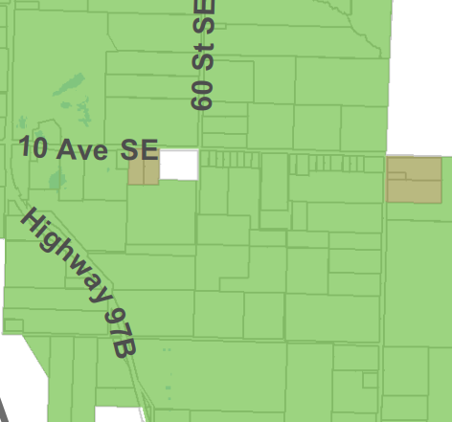
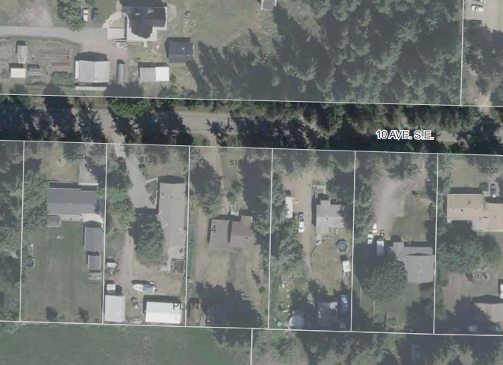
½ acre parcels
- Staff recommend that the increased density should be limited to the SSMUH parameters of two dwelling units rather than permit additional units. Should an A-2 or A-3 or even A-1 property owner wish to develop to the R-10 limit of four (or more), this should be considered through the rezoning process, including a fulsome review of OCP policy, utility services, road dedication / development, etc. This should be the case whether the land is in or out of the UCB and definitely if any part of the subject land is ALR. The provincial Policy states that the purpose of the legislation is to address the housing needs on urban serviced lands near schools and buses; rather, than enable rural (or semi-rural) sprawl and leap frog development.

- All Agriculture zones refer to the ALR regulations which have legislative supremacy over this Bylaw, over the Local Government Act and the Community Charter. This language will be maintained as will the Zoning Bylaw cap of total of all dwellings at 500 sq.m. The ALC regulation limits the area of an accessory dwelling unit at 90 sq.m. (969 sq.ft.) but this is not repeated in our Bylaw given the ALC will and does often revise their interpretations of legislation and policies.

Zone by Zone Specifics
The subsequent analysis is broken down by each Agriculture zone which is set out in a separate schedule to the one covering bylaw.
- A-1 – Agriculture Zone
The A-1 zone requires the largest minimum parcel area of 8ha (19.7ac) and applies to the horseshoe of Crown held slopes at the east, south, and west within the City boundary (see attached maps). All A-1 lands are outside of the UCB and almost all are not served by City utilities (water and sewer). While most A-1 is not ALR land, there is a significant extent of productive ALR across the southwest where the Salmon River Valley supports a range of farms (see the third attached map with overlay of ALR and A zones).
The purpose statement at the head of the A-1 Zone reads:
The A-1 Zone is intended to identify and preserve land with good agricultural or forestry potential. Development on land located in the A-1 Zone will respect the rural nature of the area.
This purpose is not proposed to change. The primary change is to Section 34.4 Maximum Number of Single Family Dwellings which should be revised to allow a principal dwelling and either a secondary suite or an accessory dwelling unit regardless of parcel area. Currently the minimum area of 8ha (20 acres) is required to enable a second dwelling unit. The A1 Zone also required the person who lives in the second unit to be employed as farm help, permanent or temporarily. Both of these requirements will be removed (whether or not the land is ALR). This condition of accessory residential use (farm help/family) is no longer in effect within the ALR. The minimum parcel areas, widths, setbacks, etc. and permitted uses are not proposed to change.

- A-2 – Rural Holding Zone
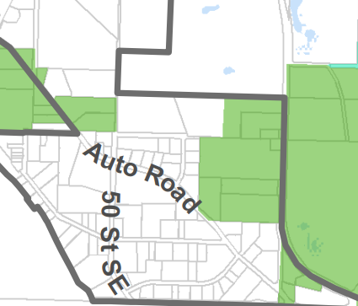
The A-2 covers the far greatest number of parcels of the Agriculture zones and includes significant tracts of ALR (Map 3 and Map 4). It includes properties both within and outside of the UCB – as shown adjacent and on the next pages. The purpose statement reads as follows:
The A-2 Zone is intended to provide predominantly residential parcels & small-scale agriculture in a rural setting.
The 4ha (10ac) minimum parcel area will remain despite the extreme range in parcel size across the 889 parcels. Some properties are truly for residential use and cannot support farming while others are viable for a range of farms. Currently, a second dwelling is allowed but only if a parcel is 8ha (19.7ac) or more in area. This would no longer be the case and all A-2 parcels would be allowed a suite or accessory dwelling.

- A-3- Small Holding Zone
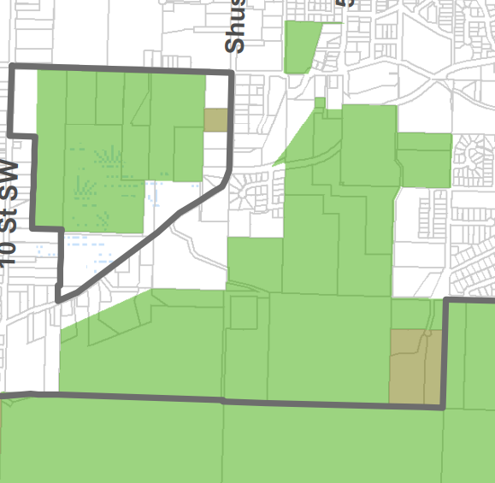
The current A-3 Zone applies to 110 parcels, most are west of 50 Street SW on the City’s western perimeter. There are three areas where A-3 parcels cluster at the UCB, one pictured at below, then there are a few parcels north of Raven by Coyote Hill Park and one at the far west edge of the UCB north of the Trans Canada Highway. Finally, there is a small island of A-3 west on the 3600 block of Lakeshore well within the UCB. A-3 Zone minimum parcel area is only 2ha (5ac), the smallest of the three Agriculture zones. The zone purpose statement reads:
A3 properties south of the City south UCB
The A-3 Zone is intended to provide for the creation of two hectare parcels in areas specified in the OCP where further urbanization and servicing is not anticipated and where the Agricultural Land Commission (ALC) has either excluded the area from the Agricultural Land Reserve or where the ALC has agreed to the A-3 Zoning.
There is a mix of A-3 within and outside of the ALR and there is a range of parcel sizes. Staff note that subdivision to a parcel size smaller than permitted in on A-3 zoned lands would require an Official Community Plan (OCP) amendment as all lands zones Agriculture are designated Acreage Reserve in the Official Community Plan.
The task of SSMUH changes to the Zoning Bylaw does not include rezoning for subdivision or interpretation of OCP policy. The OCP review process is underway and the process is typically followed by zoning bylaw amendment, through which development, land use, and subdivision policies are properly established.

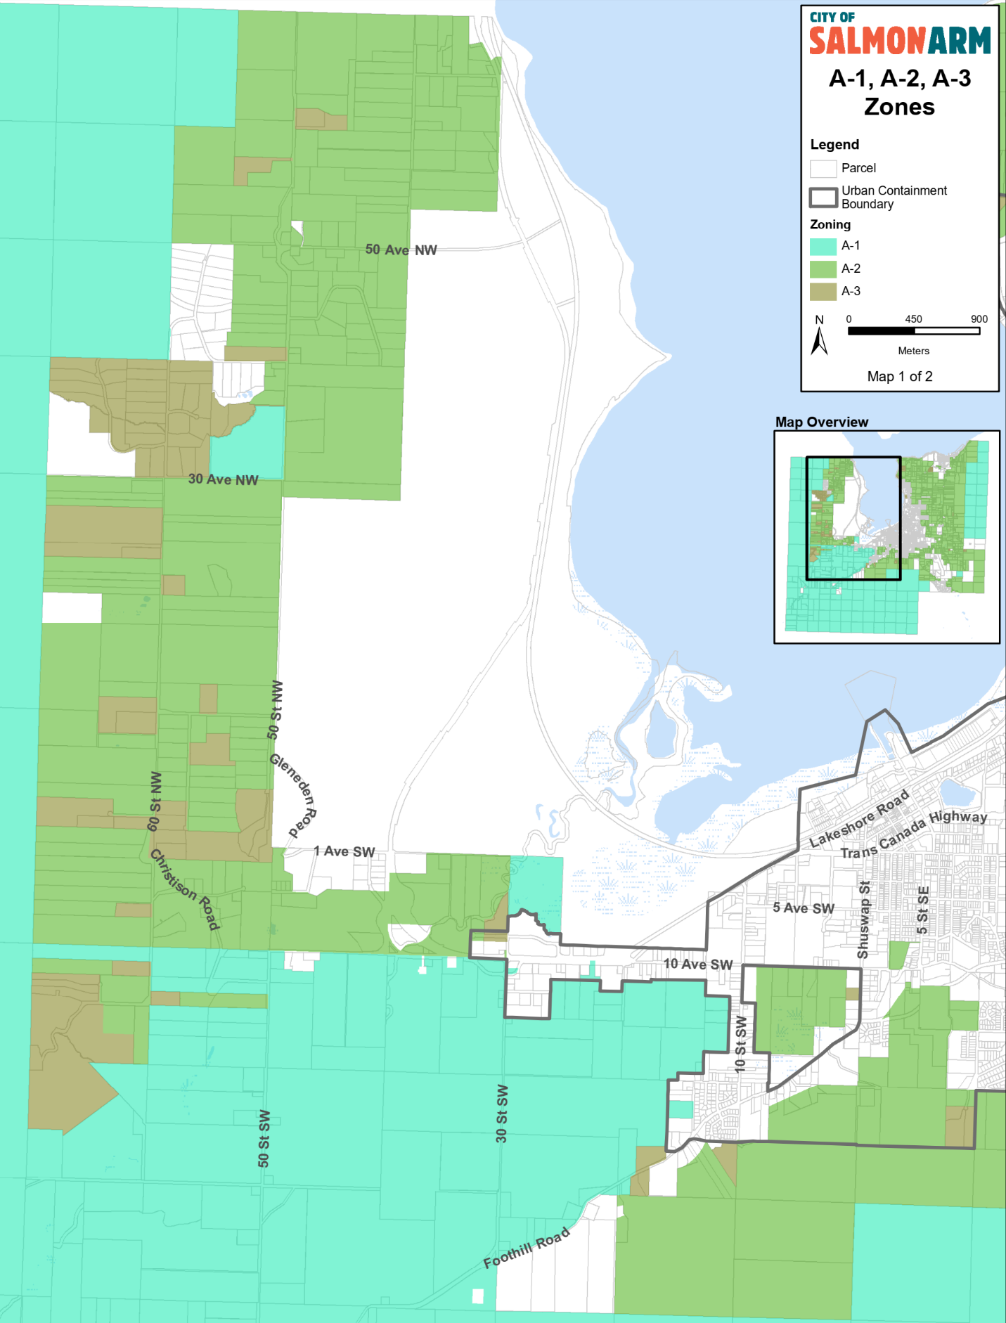
Map 1

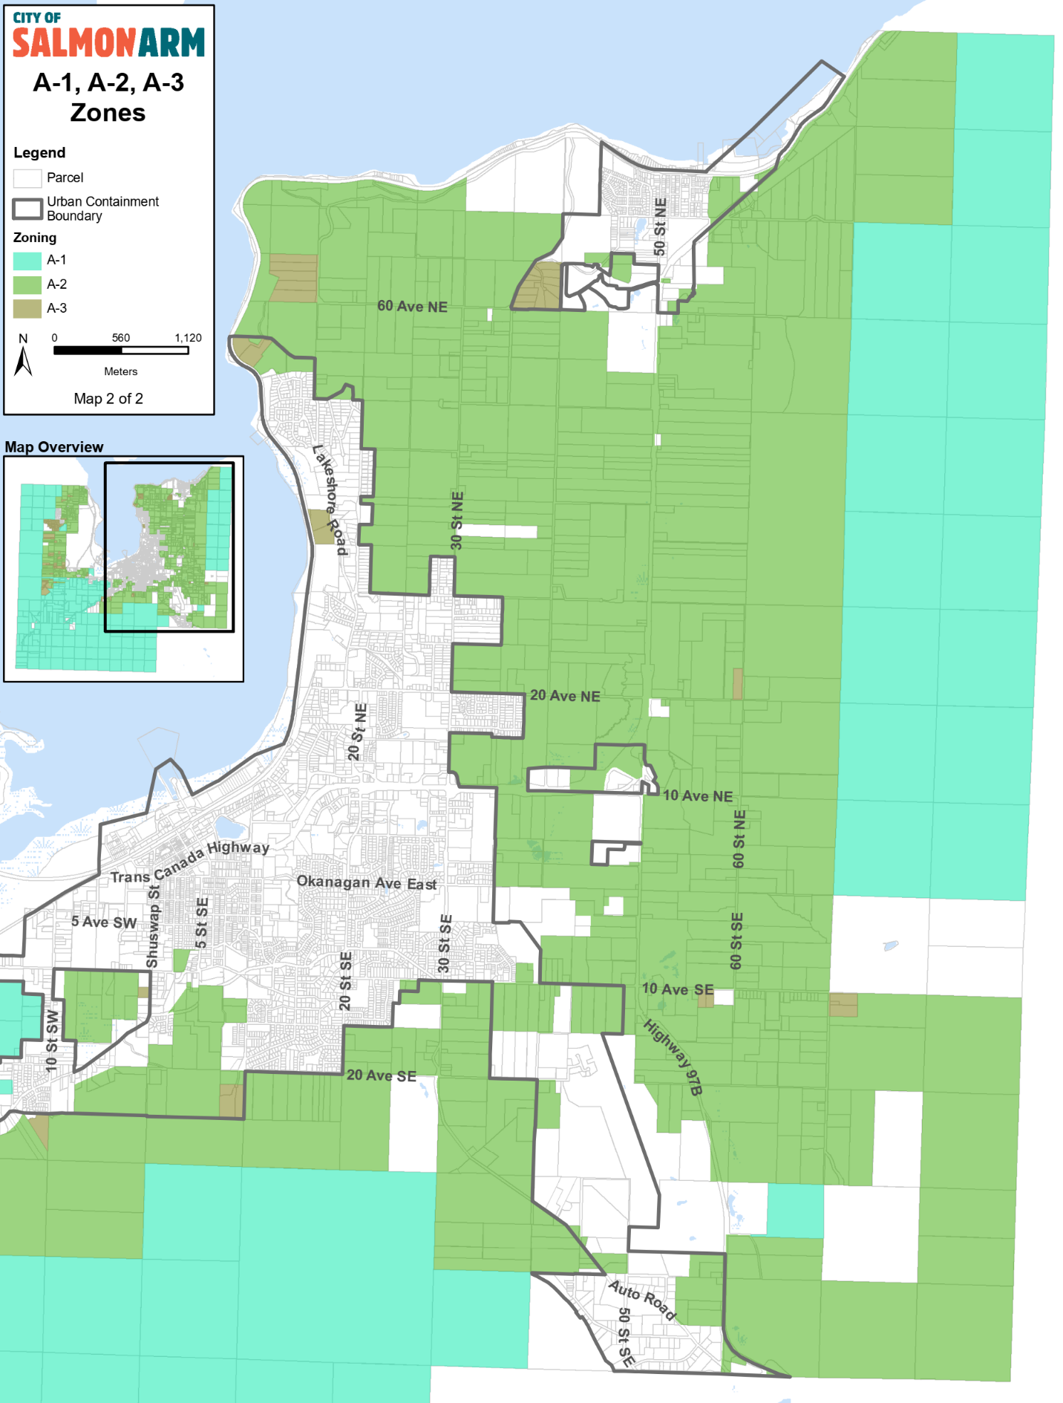
Map 2

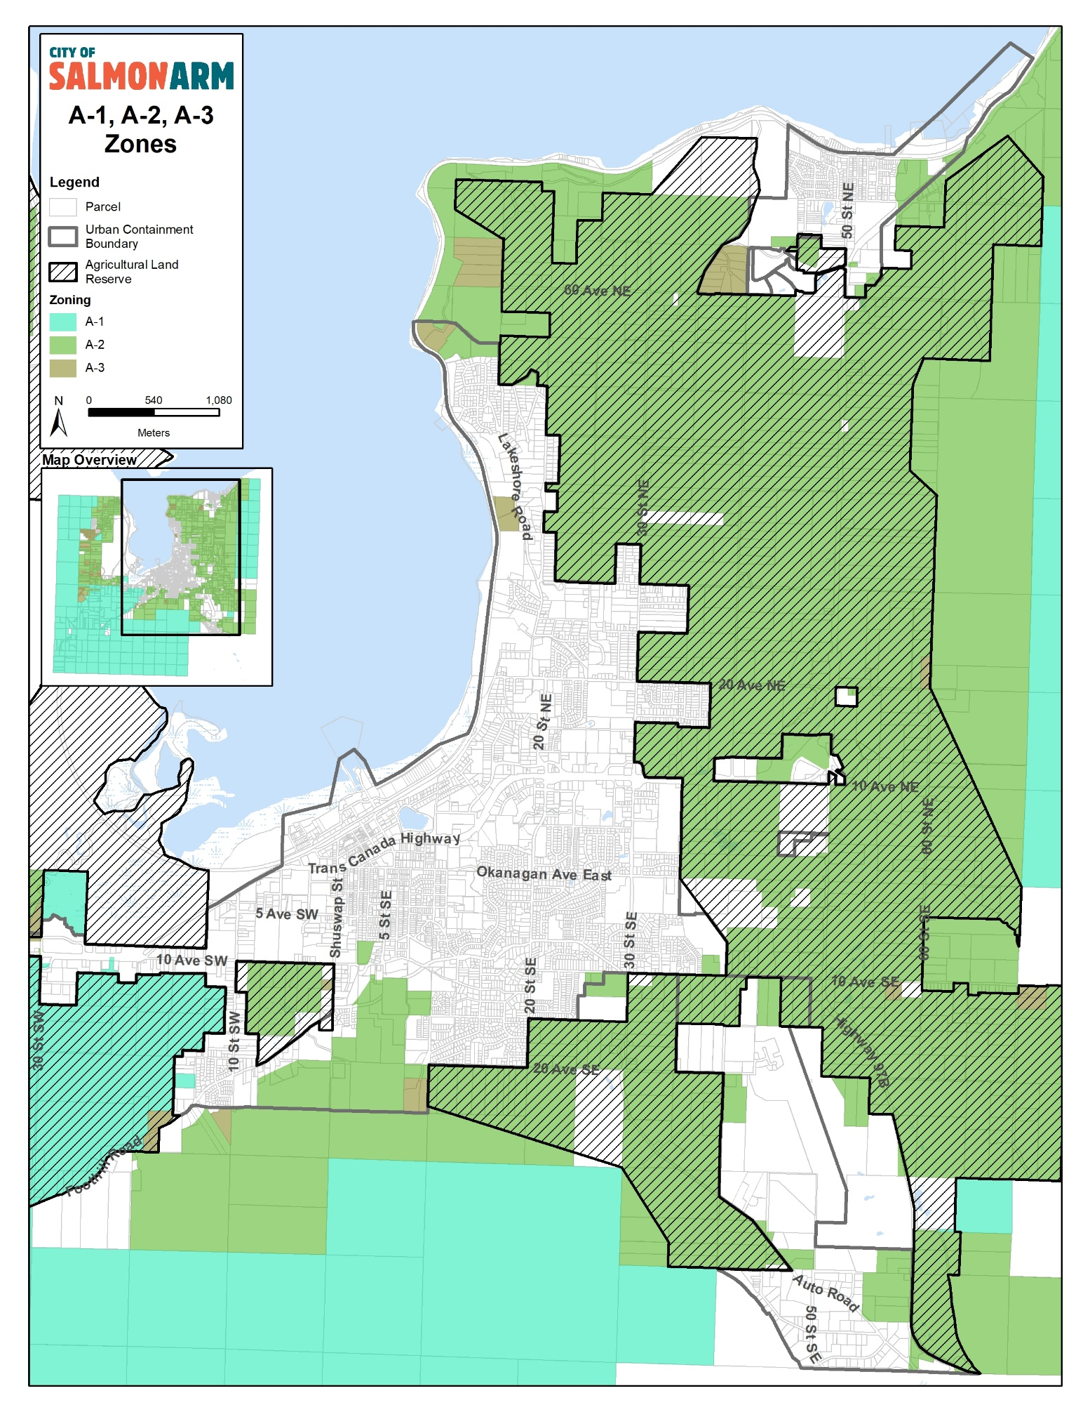
Map 3
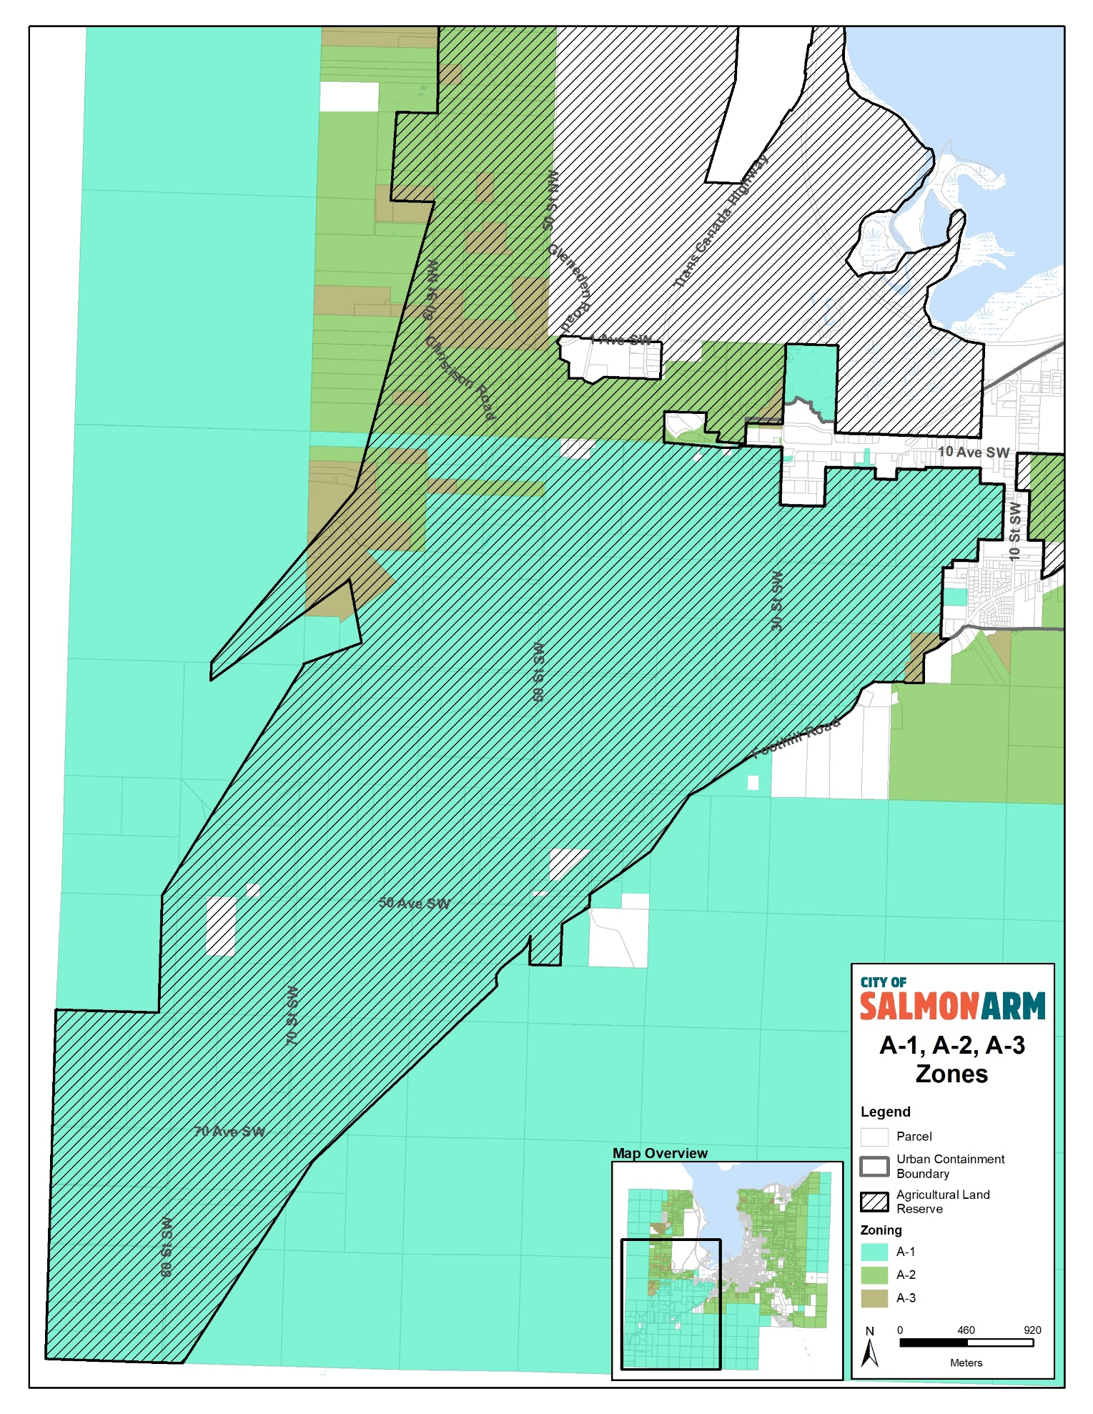
Map 4
Relevant Policy(ies):

Prior to the June 30, 2024 deadline zoning and other bylaws will be brought forward for Council’s consideration that would be utilized by Council, staff and the public to review and approve Small Scale Multi Unit Housing (SSMUH).

Referral Comments:
In the drafting of the various bylaws related to SSMUH, planning staff consulted with staff.

Fire Department

N/A

Building Department

N/A

Engineering Department

N/A

Other

N/A

Planning Department
In closing, this aspect of SSMUH comprises relatively minor changes as compared to the changes in the single family Residential zones and staff do not foresee the proposed amendments to be controversial. These three Agriculture zones are made simpler.
Advancing the attached proposed Bylaw to Council for first and second reading would place it on the agenda and continue the process in order to meet the June 30, 2024 deadline.

Financial Considerations:
N/A

Committee Recommendations:
N/A

Public Consultation:

The Local Government Act prohibits Council from holding a Public Hearing for bylaw amendments that are for the sole purpose of implementing bylaw amendments related to SSMUH. Notice will be given in two consecutive editions of the newspaper in advance of Council considering first reading of the proposed bylaw. It is expected that first reading will be considered that the May 13, 2024 Regular Council meeting.

Alternatives & Implications:
N/A

Prepared by: Planning Analyst & Manager of Planning and Building
Reviewed by: Director of Planning & Community Services
Approved by: Chief Administrative Officer

Attachments:
- Appendix 1 – Draft Bylaw No. 4656

