REQUEST FOR DECISION
To: Development & Planning Services Committee
From: Planning Analyst and Manager of Planning and Building
Title: ZON 1289/ZON1290 (SSMUH) R-13 (R-3), R-17 (R-7) and R-19 (R-9) Zones
Date: April 15, 2024

Executive Summary/Purpose:
This report sets out the next stage of the required amendment of Zoning Bylaw 2303 to meet the Small Scale Multi Unit Housing (SSMUH) legislation. Following the logic of the proposed R-10 Residential Zone, it explains how the following three single family residential zones are proposed to change:
R-3 – Waterfront Residential to R-13 – Lakeshore Residential
R-7 – Large Lot Single Family Residential to R-17 – Large Parcel Residential
R-9 - Estate Residential to R-19 – Estate Residential

Motion for Consideration:

THAT: a bylaw be prepared for Council’s consideration that will replace the R-3 (Waterfront
Residential) zone with R-13 – Lakeshore Residential, R-7 (Large Lot Single Family Residential) with R-17 (Large parcel Residential) and R-9 (Estate Residential with R-19 (Estate Residential).

Staff Recommendation:
That the motion for consideration be adopted.

Background:
The Housing Amendment Statute, formerly Bill 44, is accompanied by a 95 page manual (the “Policy”) which details the standards that must be considered by municipalities when making the necessary bylaw changes to meet the increased densities across what is now one and two family residential zoning.

While density is prescribed by legislation, other zoning provisions remain under municipal authority. The key is that these must not undermine the spirit or intent of the density changes. The Policy site standards that needs to be considered in making the bylaw changes, include:
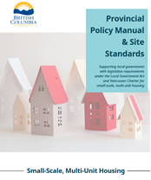
- Building type/form – recommend to be more broad and permissive
- Parcel setbacks – recommend to keep to minimum
- Building height/number of storeys –recommend 3 storey
- Parcel coverage – recommend ~50%
- Floor area ratio – recommend to eliminate this zoning provision
- Off-street parking requirements – recommend to reduce

The Policy is drafted with a clear focus on large urban centres with small parcels, little snow, and frequent transit and not estate properties.

Current R-7 and R-9 residential lands are within the Urban Containment Boundary (UCB), while those of the R-3 are outside the UCB. The differing attributes, development, and parcel sizes between these three zones mean that it is advisable to maintain the separate zones. The parcel count follows:
R-3 11 parcels (east of the marina on 73 Ave NE between the lakefront and
railway)
R-7 140 parcels (in Raven and Hillcrest neighbourhoods)
R-9 14 parcels (above Raven and two on west edge of Canoe)

The terminology and frontend General Regulations that were a part of the R-10 changes (e.g. permeability provisions/definition and accessory dwelling unit or ADU provisions/definition) have also been applied to this proposed Bylaw. A more detailed analysis of the definitions can be found in the Report dated April 2, 2024 (Bylaw 4653).

ANALYSIS
For clarity, the subsequent analysis is broken down by each zone which is set out in a separate schedule to the one covering bylaw. While all three zones have increased density, only the R-17 will enable up to four dwelling units as prescribed by legislation. The R-13 and R-19 will double to allow two units for the reasons set out below.

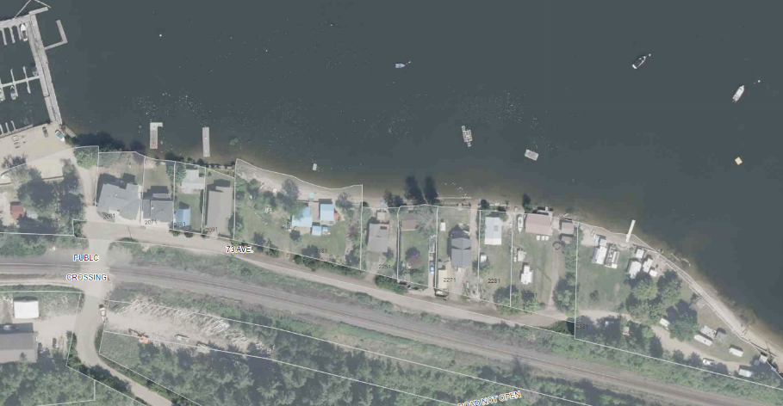
R-13 - Lakeshore Residential
The R-13 zone replaces the R-3 Zone as applied to 11 historic parcels all subject to floodplain and riparian protection legislation. These limitations continue and are not superseded by SSMUH; rather, these are a complicating layer over SSMUH.
R3 properties on Shuswap Lakefront in Canoe
As illustrated above, there is a range of parcel area and age of development. The more historic dwellings, sited at the water’s edge, would not be allowed to rebuild in their current location under current legislation. This is a unique zone, created specifically for this stretch of properties.
Currently, the R-3 zone allows one single family dwelling. This will double to allow a secondary suite. Since this area is outside the UCB, three or four dwelling units are not legislated or contemplated – and would be difficult to achieve in most cases. Given ADUs have proven to be problematic due to the site constraints, staff recommend allowing each property to potentially add one secondary suite only. The added density of a suite is attainable and should be permitted, noting that a suite’s floor structure must be developed above the floodplain and within an existing dwelling. If constructed onto or alongside the dwelling, it will likely require provincial submission and approval of a riparian area report.
The required minimum parcel area of 400 sq.m. is not proposed to change nor are other parameters, setbacks, etc. of this zone. The replacement R-13 zone is proposed to no longer regulate floor area ratio but similar to the R-10 Zone, would require at minimum 40% parcel permeability. Based upon the 2023 aerial imagery, the subject lands would all comply. The Riparian Area Protection Act does not allow hard-scaping of the 30 metres beyond the natural boundary of the lake in any event.
R-17 – Large Parcel Residential
There are 140 parcels zoned R-7, mainly in Hillcrest and Raven, as pictured below. There are also seven lakefront R-7 parcels east of the wharf along Harbourfront Drive. No R-7 parcels are smaller than the Bylaw area but one is over an acre. All are serviced and within the UCB.
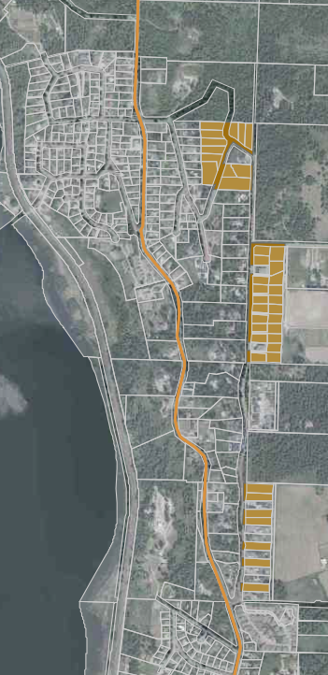
The stated purpose of this Zone is to allow single family dwellings on large parcels (i.e. 1,330 sq.m. or 1/3 acre), three times the minimum area of the R-10 zone covering most of Salmon Arm serviced residential land. Staff note that these areas are bylaw minimums – most properties are actually much larger (e.g. Hillcrest lots are ½ acre). Should landowners elect to develop, many of these parcels will be able to accommodate additional dwelling units even if the principal dwelling is large and sited squarely in the middle of the parcel.
R-7 parcel area and setbacks parameters are not proposed to change; however, parcel coverage and permeability should be addressed. The draft Bylaw R-17 Zone requires as follows:
1. 40% maximum parcel coverage of all buildings,15% for ADUs and 10% for accessory buildings;
2. 50% of parcel to be permeable, leaving 10% for impervious decks, driveways etc. where and if developed to the cap;
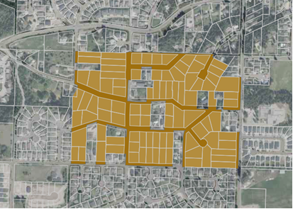
3. R-7 building setbacks are carried through to the R-17 as well as to ADUs which must be 6m from rear, front and exterior side property lines and 4m for side property lines that are shared with another residential property.

R-19 – Estate Residential
The current R-9 Zone applies to 12 properties in the Raven area and two parcels along Park Hill Road, all are within the UCB and serviced or potentially serviced should development proceed. The subject lands are identified in blue on the adjacent aerial maps. Currently the R-9 zone allows a single family dwelling only.
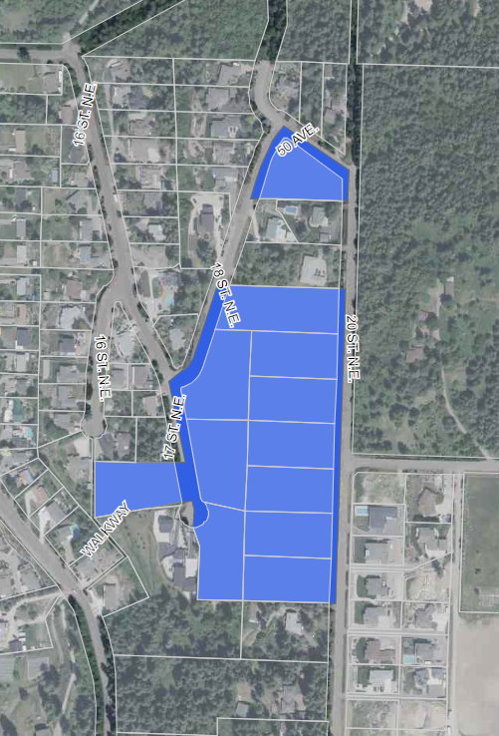
Under SMMUH legislation, larger parcels are not required to allow anything over two dwelling units: a principal dwelling and either a secondary suite or an accessory dwelling unit. This limit on parcels over one acre is to protect orderly future subdivision, including provision of utilities, sidewalks, road/trail dedications, etc. It parallels the default density increase across all rural and semi-rural zones outside the UCB; in smaller municipalities (under pop. 5,000) and across residential zones of the CSRD, where two dwelling units, either a secondary suite or an accessory dwelling unit, will be permitted.
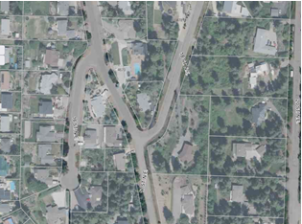
R-9 parcel parameters are carried through to the R-19 replacement zone, including the present 15% parcel coverage and greater setbacks. These setbacks will now also apply to the newly incorporated option of an ADU. Finally, the requirement for 60% permeable surfaces has been added to the R-19 Zone. As shown on the image below, these parcels have significant permeable area with open treed yards. The topography and the soils/geo-technical conditions across many of the R-19 Zone parcels will require careful consideration and professional review to add accessory dwelling units or dwelling additions.
R-19 Density
In future Council may consider increasing zoning beyond the limit of two units (for example a secondary suite and an ADU), but this is not recommended at this time as it may complicate the process given it exceeds legislation; moreover residents may or may not support added density.
These changes could follow a separate focused process, subject to the policy of the new OCP.

Permitted Uses
The three zones, R-13, R-17, and R-19, each have a current list of permitted uses that will carry forward; for example, a variety of childcare uses, limited bed and breakfast provisions, boarders (i.e. roommates), or home occupations. These are included in the replacement zones. The work of SMMUH is not to change permitted land uses but to enable more density and more long term housing.
Staff are working on bylaw amendments which would allow for “uses allowed in all zones” to address public utilities, public uses and parks. These amendments are necessary to ensure conformity within the zones; however, are outside of the mandate of the SSMUH legislative changes so will be brought forward after the SSMUH residential zones are near adoption or have been adopted.
In the proposed R-10 Zone, likewise in the three zones in this report, staff have tried to assure clarity in what can and cannot happen in the principal dwelling versus in an accessory dwelling unit in a yard. For example, bed and breakfast use can happen only in the principal dwelling while residents may have a boarder in their ADU or a roommate in a secondary suite. As set out in the R-10 report and the General Regulations, ADUs are for residents and for month to month rental and cannot be used as a short term rental. Platforms such as Air-BnB are used to post traditional bed and breakfast operations. This is permitted now and will continue to be allowed in future; however, short term rentals for a week or a weekend of an entire dwelling unit is not permitted at present in Zoning Bylaw 2303; moreover, it is discouraged by the new legislation.
Council may wish to examine the entire bylaw and provincial regulatory framework of short term rentals in the future, after the SSMUH work is complete.
In closing, this round of changes will have less impact across the entire City that the previously discussed R-10 Zone but it will enable some localized increases in density, particularly in the R-17 Zone.

Relevant Policy(ies):

Prior to the June 30, 2024 deadline zoning and other bylaws will be brought forward for Council’s consideration that would be utilized by Council, staff and the public to review and approve Small Scale Multi Unit Housing (SSMUH).

Referral Comments:
In the drafting of the various bylaws related to SSMUH, planning staff consulted with staff.

Fire Department

N/A

Building Department

N/A

Engineering Department

N/A

Other

N/A

Financial Considerations:
N/A

Committee Recommendations:
N/A

Public Consultation:

The Local Government Act prohibits Council from holding a Public Hearing for bylaw amendments that are for the sole purpose of implementing bylaw amendments related to SSMUH. Notice will be given in two consecutive editions of the newspaper in advance of Council considering first reading of the proposed bylaw. It is expected that first reading will be considered that the May 13, 2024 Regular Council meeting.

Alternatives & Implications:
N/A

Prepared by: Planning Analyst
Reviewed by: Manager of Planning and Building
Reviewed by: Director of Planning & Community Services
Approved by: Chief Administrative Officer

Attachments:
- Appendix 1 – Draft Bylaw No. 4655

